Task Assignment
EV3 “Line Follower”
Team/Robot Name__________________________________________
Team Member’s Names______________________________________
As a team, work to develop the programs outlined below. Each of these completed programs must be demonstrated to one of the other teams. That team will then sign off indicating your program was successful.
Complete the Line Track Challenge. When you have completed this challenge, have another team check it off before arranging with the teacher for your demonstration. Be prepared to discuss your Flow Chart, EV3-G program details and how you overcame any difficulties that arose.
Date | Program | Sign-off
 | Mini Challenge: Track Line for Rotations
Date | Challenge | Sign-off
 | Line Track Challenge
 | Successful Line Track Challenge Completion!!!  Best time:________ | (Teacher)

Obstacle Course
During your teacher sign off, be prepared to use your Flow Chart and comments in your EV3-G program to show how you tackled the challenge.

Date | Challenge | Sign-off
 | Obstacle Course Challenge
 | Successful Obstacle Course Challenge Completion!!!  Best time:________ | (Teacher)
Slalom Challenge
During your teacher sign off, be prepared to use your Flow Chart and comments in your EV3-G program to show how you tackled the challenge.

Date | Challenge | Sign-off
 | Slalom Challenge
 | Successful Slalom Challenge Completion!!!  Best time:________ | (Teacher)
The Captain’s Buried Treasure, Part 3
Use the layout provided to develop and demonstrate your work. During your teacher sign off, be prepared to use your Flow Chart and comments in your EV3-G program to show how you tackled the challenge.
Date | Challenge | Sign-off
 | Successful Challenge Completion
 | SUCCESSFUL TREASURE HUNT (“X” marks the spot)!! | (Teacher)
Extreme Line Following
- This event will take place on a ~4’x4’ whiteboard with the line constructed of ¾” electrical tape. The course will include long straight-aways, curved turns, and sharp angled turns (see drawing below).
- Robots will begin with the press of the “Start” button (rather than starting “gun” as described in the original NXT challenge) and the time over the course will be recorded when the robot comes to a stop after touching the stop-block.
- Robots must continuously use a light sensor to follow the line, but may use any other sensor(s) to supplement performance.
- No external stimuli may be supplied during the run.
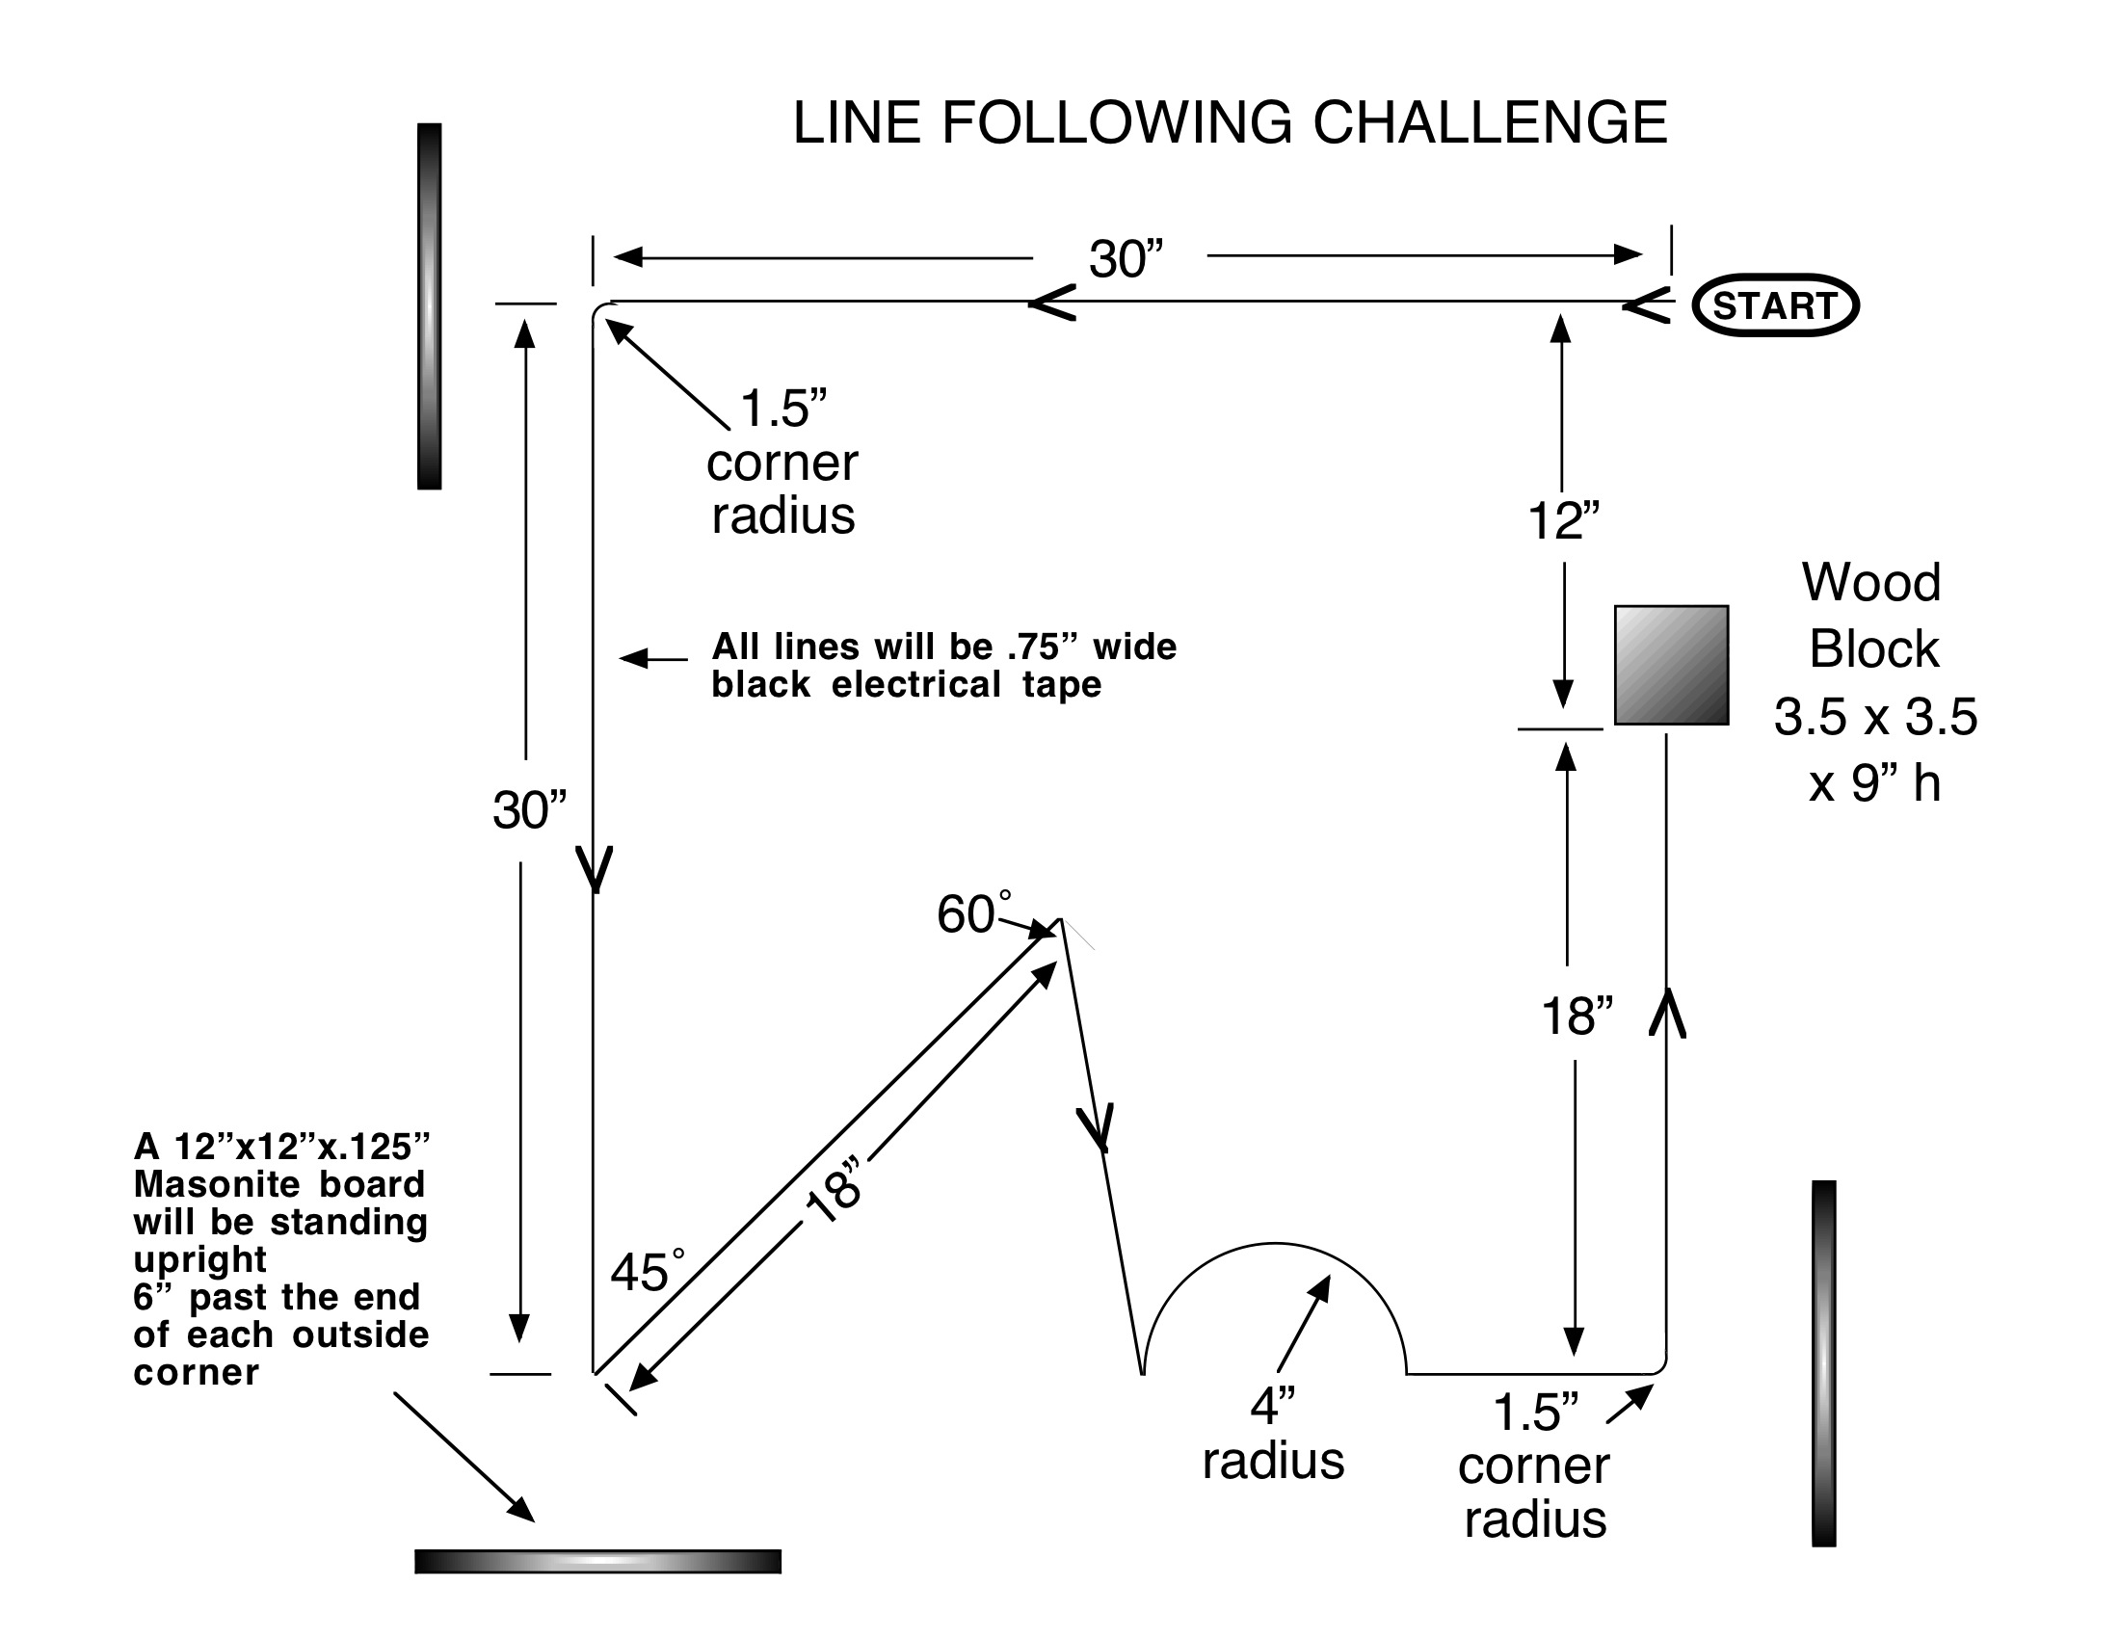
Use the layout provided to develop and demonstrate your work. During your teacher sign off, be prepared to use your Flow Chart and comments in your NXT-G program to show how you tackled the challenge.
Date | Challenge | Sign-off
 | Extreme Line Following
 | Successful Extreme Line Following Completion!!!  Best time:________ | (Teacher)

